Software Deployment AT1.5

30003389 – Kyer Potts

Table of Contents

Table of Contents i

Create Installation Package 1

Installation Test Environment 2

Software Uninstallation 4

# Create Installation Package

1. Determine the location of the source files
   1. 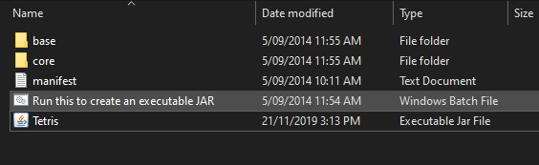
2. Create a manifest.txt file with this information, ensure that the file ends in a new line
   1. 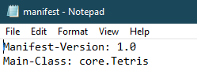
3. Create a batch file and include the following:
   1. 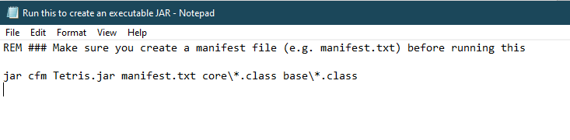
   2. Ensure that the manifest.txt file has been created correctly before running the batch file.
4. Run the newly created batch file. This will generate the JAR executable file
   1. 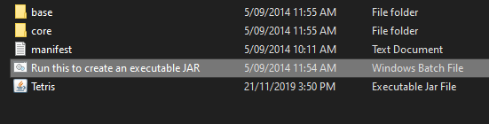
5. Open the newly created Tetris JAR Executable file to run the program
   1. 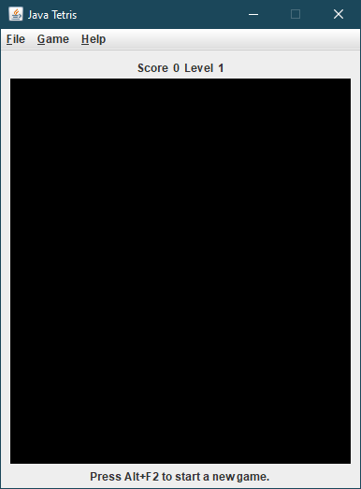

# Installation Test Environment

1. The JAR file has been created, but in order to run it, the Java platform must be installed on the system. To install Java on Windows 10, go to <https://www.java.com/en/download/win10.jsp> and click the Java download button.
   1. 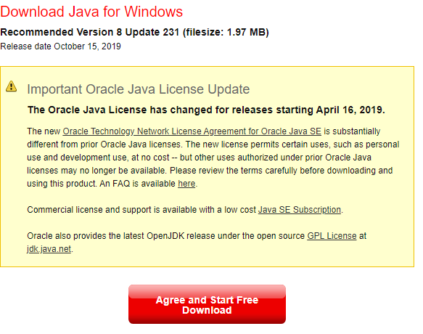
2. Once the Java Setup file has finished downloading, run the file to begin the installation process
   1. 
   2. 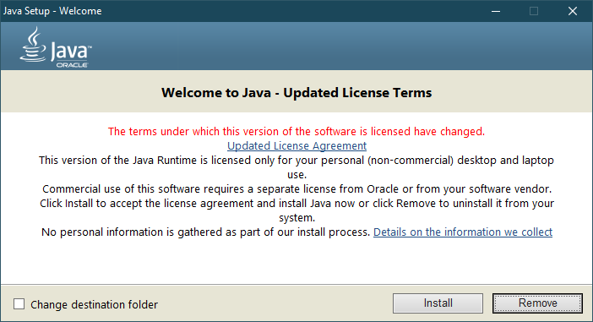
3. Follow the steps to install Java onto the system
4. Copy the Tetris Jar Executable file onto your system
   1. 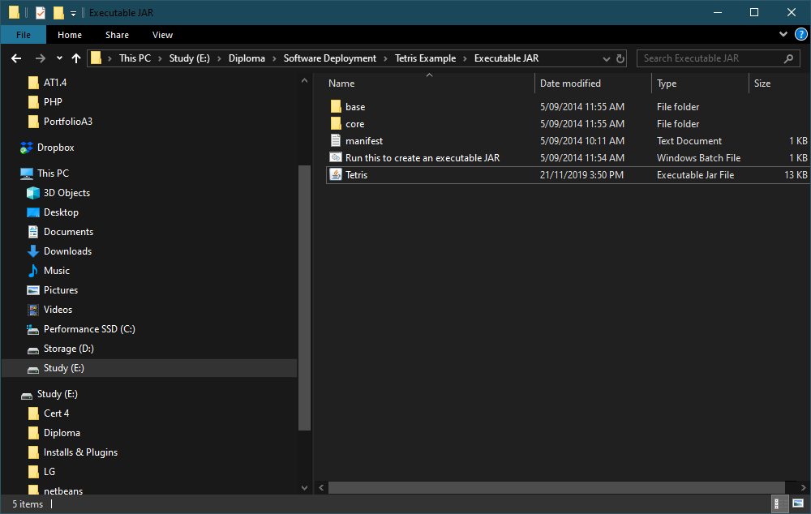
5. Run the JAR file to begin the program
   1. 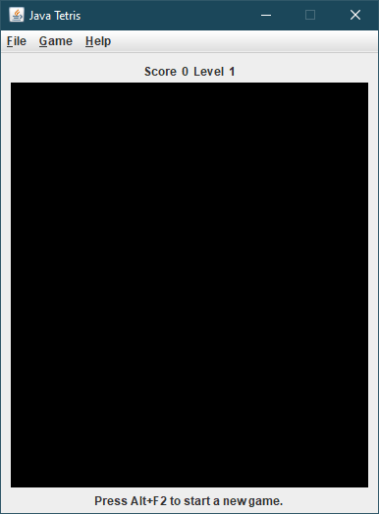

# Software Uninstallation

To uninstall the Tetris game, simply delete the Tetris Executable JAR file from the system

